# Travel & Tours

# 

# 

|  |  |  |
| --- | --- | --- |
| **Supervisor** | SIR MUHAMMAD HARIS | |
| **Batch** | 2401G3 | |
| **Group** | **C** | |
| **Serial No.** | **Enrollment Number** | **Student Name** |
| 1. | Student1547443 | MISS AYESHA NAZ |
| 2. | Student1551007 | MR. MUHAMMAD AYAAN MEHFOOZ |
| 3. | Student 1546909 | MR. MUHAMMAD HAMMAD SHAHID |
| 4. | Student1549513 | MISS MALIHA TAHIR |

# Problem Statement:

Pleasant Tours is into selling various tour products. They have predefined tours with itineraries.

The company advertises by distributing pamphlets, advertising on television, and so on. to hotels, etc.

Due to rapid development in the internet field, the company decided to launch a website where people will get all the information about the various tour products available with them easily. requirement specifications.

The website is to be developed for the Windows Platform using HTML5, JavaScript

and Geolocation. The site should work well in all leading browsers including Chrome,

IE, Firefox etc.

Requirement Specification:

The Web site is to be created based on the following requirements.

1) The Home Page should be created by making use of Section graphics and a suitable logo

2) The site should display a menu that will contain the options for a brief introduction about the various products available, the location of the shop, and any other information if required.

3) The information should be categorized according to different types of products if a User wants to see only ‘Beach Tours’ then he clicks on a Link/button/menu etc. and he will see different types of beach tours. Similarly, for ‘Hill Stations’, ‘Forts/Palaces’, and other products

4) When a user selects any product type, a list of products for that product type will be displayed.

5) The itinerary of individual tour products should be displayed on the Web Page along with the title but detailed itinerary should be stored in Individual Word documents which can be downloaded or viewed by the User who wishes to see the same.

6) Price Lists for all tours should be available for download.

7) There should be a “Contact Us” page which will have the Address of the Company which is as follows and the mail address which when clicked will invoke the local mail client from where they can send an email.

**Hardware/ Software Requirements**

**Hardware**

* A minimum computer system that will help you access all the tools in the courses is a Pentium 166 or better
* 64 Megabytes of RAM or better

**Software [Either or Combination as per Course/Sem]**

* Notepad/HTML editor/Coffee Cup
* Angular / Angular JS / React / Bootstrap
* Dreamweaver / Figma
* MS IE / Chrome / Firefox / Netscape /MS Edge

**Acknowledgement:**

**We are excited to develop a state-of-the-art responsive website for Travel & Tours, the world's premier online travel agency specializing in luxury travel experiences, exotic destinations, and bespoke tours. Our team's expertise in HTML5, JSON, JavaScript, and Geolocation, along with a commitment to cross-browser compatibility, ensures that we will create a user-friendly platform. This platform will simplify the process of discovering and booking exclusive travel packages while streamlining the reservation process and reducing paperwork. We are eager to collaborate with Travel & Tours to bring this vision to life and provide travelers worldwide with a modern, efficient, and enjoyable booking experience.**

**Synopsis:**

**We are excited to develop a state-of-the-art responsive website for Travel & Tours, the world's premier online travel agency specializing in luxury travel experiences, exotic destinations, and bespoke tours. Our team's expertise in HTML5, JSON, JavaScript, and Geolocation, along with a commitment to cross-browser compatibility, ensures that we will create a user-friendly platform. This platform will simplify the process of discovering and booking exclusive travel packages while streamlining the reservation process and reducing paperwork. We are eager to collaborate with Travel & Tours to bring this vision to life and provide travelers worldwide with a modern, efficient, and enjoyable booking experience.**

**Introduction:** In response to the growing demand for a user-friendly and efficient online platform for luxury travel experiences, this project aims to develop a responsive website for Travel & Tours. As the world's leading travel agency in its category, Travel & Tours seeks to enhance the experience for travelers worldwide by simplifying the booking process and streamlining travel arrangements. Our goal is to provide a seamless, modern, and enjoyable platform for discovering and reserving exclusive travel packages, ensuring a hassle-free and memorable journey for every customer.

**User Interface:** The heart of this project lies in creating an intuitive and engaging user interface. Leveraging HTML5, JSON, JavaScript, and Geolocation, our team will design a dynamic and visually appealing website that offers real-time pricing and ensures a seamless experience across various browsers, including Chrome, IE, Firefox, and more

**Conclusion:** In conclusion, this project represents a transformative step forward for Travel & Tours. By leveraging cutting-edge technology and a user-centric approach to website development, we aim to maximize profitability for our client and provide travelers worldwide with a modern, efficient, and convenient platform for booking their dream vacations. This endeavor signifies our commitment to excellence, and we look forward to delivering a website that not only meets but exceeds the expectations of Travel & Tours and its valued customers.Top of Form

Top of Form

**Sitemap:**

**Travel & Tours Agency**

Services

Home

Book

Packages

­

Contact

Gallery

About

Luxury Resorts

Private Villas

All-Inclusive Resorts

Services

Mountains

Forts

Hill Stations

**Carousel:**



**Navbar:**



There are seven essentials listed here, and you will be redirected to all the pages, which are further classified as:

* Home
* Book
* Packages
* Services
* Gallery
* About
* Contact Us
* Categories

**About Us:**

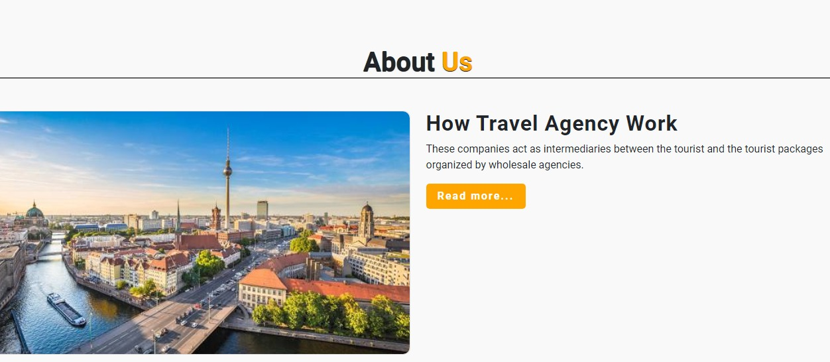

**Booking:**

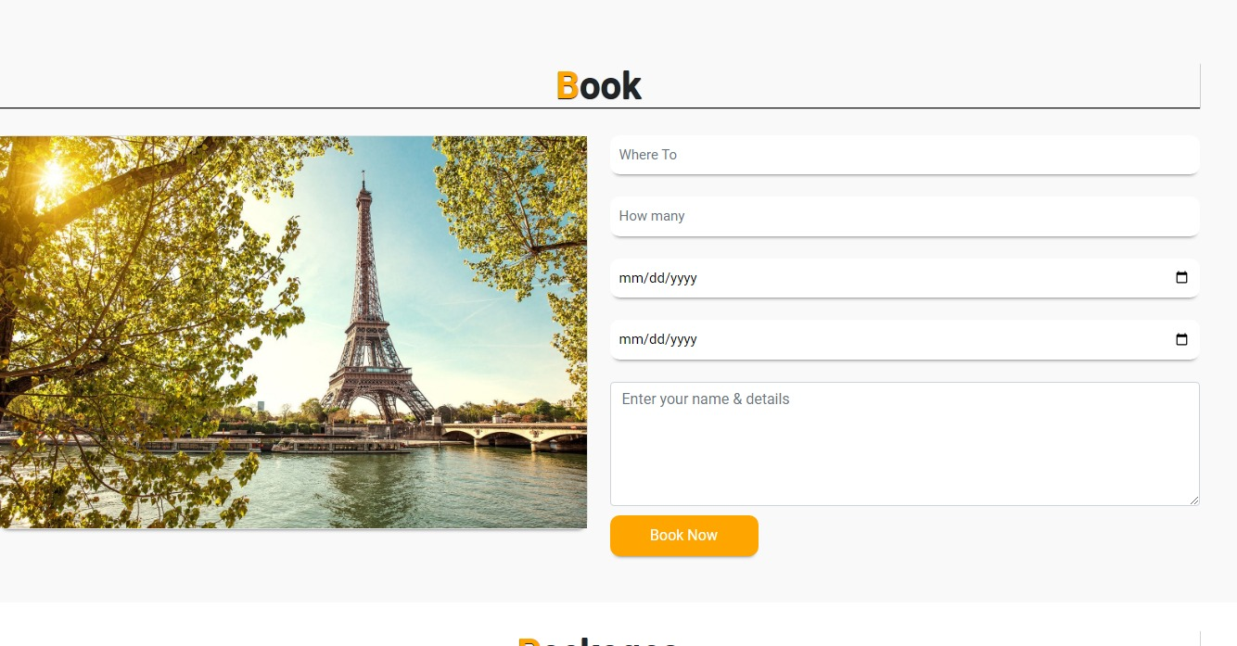

**Contact Us:**

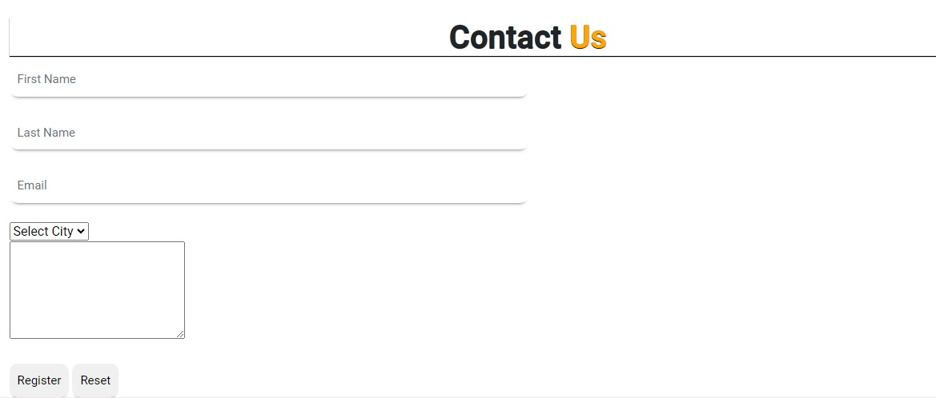

**Footer:**



**Task Sheet Review:**

|  |  |  |  |  |  |  |
| --- | --- | --- | --- | --- | --- | --- |
|  | | **Project Title** | **Date of Preparation of Activity Plan** | | | |
| No. | **Task** | **Travel & Tours** | Actual | Actual | Name | Status |
| Start date | Days |
| 1 | Navbar & Footer | Travel & Tours | 04/Jun/24 | 5 | Miss. Ayesha & Mr. Hammad | Complete |
| 2 | Build Home Page | Travel & Tours | 04/Jun/24 | 2 | Miss. Ayesha | Complete |
| 3 | Carousel | Travel & Tours | 04/Jun/24 | 2 | Miss. Ayesha | Complete |
| 4 | About Us | Travel & Tours | 04/Jun/24 | 3 | Mr. Ayaan | Complete |
| 5 | Contact Us | Travel & Tours | 04/Jun/24 | 2 | Miss. Maliha | Complete |
| 6 | Build Categories Page | Travel & Tours | 04/Jun/24 | 3 | Miss. Maliha | Complete |
| 7 | Packages | Travel & Tours | 04/Jun/24 | 1 | Miss. Maliha & Mr. Ayaan | Complete |
| 8 | Fort | Travel & Tours | 04/Jun/24 | 2 | Miss. Ayesha | Complete |
| 9 | Mountains | Travel & Tours | 04/Jun/24 | 4 | Miss. Maliha | Complete |
| 10 | Gallery | Travel & Tours | 04/Jun/24 | 5 | Mr. Hammad | Complete |
| 11 | Services | Travel & Tours | 04/Jun/24 | 6 | Mr. Ayaan | Complete |
| 12 | Hill Station | Travel & Tours | 04/Jun/24 | 4 | Miss. Ayesha | Complete |
| 13 | Categories | Travel & Tours | 04/Jun/24 | 2 | Miss. Maliha | Complete |
| 14 | Packages | Travel & Tours | 04/Jun/24 | 2 | Mr. Ayaan | Complete |
| 15 | Booking | Travel & Tours | 04/Jun/24 | 4 | Mr. Hammad | Complete |
|  |  |  |  |  |  |  |

**Summary:**

**In collaboration with Oxford Travel, a global leader in crafting exceptional travel experiences, our team is thrilled to embark on an innovative project to develop a state-of-the-art Single-Page Application (SPA) and responsive website. Our expertise in cutting-edge technologies such as HTML5, JSON, JavaScript, and Geolocation fuels our enthusiasm to deliver a revolutionary platform that will transform the way travelers discover and book their dream vacations. Our primary goal is to simplify the process of exploring travel destinations, booking tours, and finding accommodations, making it more user-friendly and efficient than ever before. We are dedicated to ensuring seamless access across all major browsers including Chrome, Firefox, Safari, and Edge, and delivering a visually stunning and responsive design that looks great on desktops, tablets, and smartphones. This project represents a significant step forward in creating a streamlined and enjoyable travel booking experience, helping travelers effortlessly plan their adventures and explore new destinations. With our innovative approach, we aim to make Oxford Travel the premier choice for travelers seeking unforgettable experiences and exceptional service in the global travel and tourism market.Top of Form**